Name | Soham Joshi
Roll no | 24204C0021
Batch | 1
Subject name | Python Programming & Data Structure
Teacher Name | Ms. Rasika Patil

Experiments | 12
Title | Implement searching techniques using python  a) Linear Search  b) Binary Search

Programming Questions with Answer
1 | Program for Linear Search
SCRIPT | 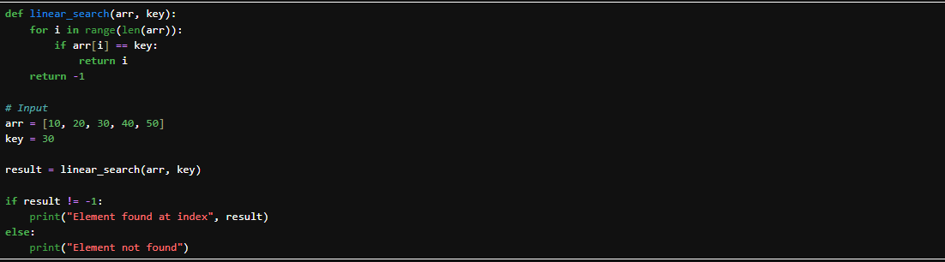
OP | 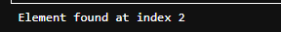
2 | Program for Binary Search
SCRIPT | 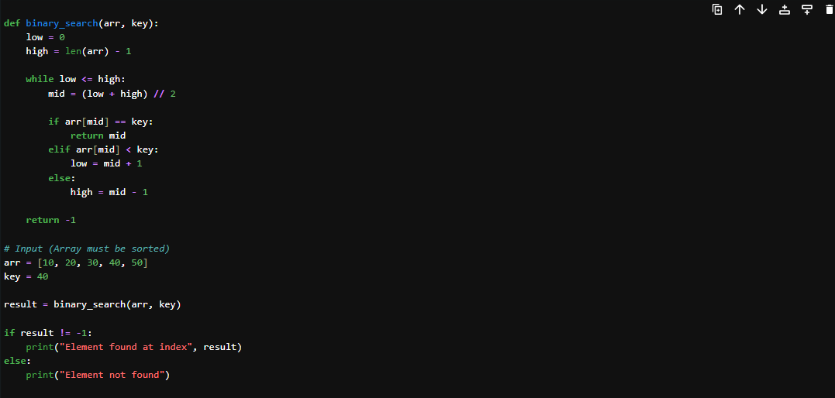
OP
3 | Program to search for a character in a string (Linear Search logic)
SCRIPT | 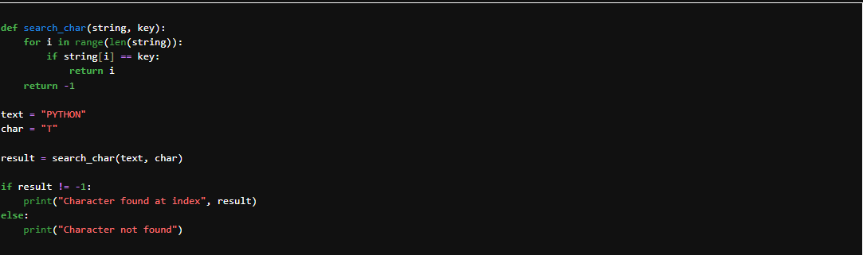
OP
Debugging Questions with Corrected Answers
1 | Debug the following code  Wrong code:  arr = [1,2,3]  for i in arr:  if arr[i] == 2:  print("Found")
OP | Error: IndexError: list index out of range  Correct code: arr = [1,2,3]  for i in arr:  if i == 2:  print("Found")
2 | Debug the following code  Wrong code:  low = 0  high = len(arr)  mid = (low + high) / 2
OP | Error: TypeError: list indices must be integers or slices, not float  Correct code: low = 0  high = len(arr) - 1  mid = (low + high) // 2
Conclusion | In this experiment, we successfully implemented:  - Linear Search (Sequential searching method)  - Binary Search (Efficient searching for sorted arrays)  - Character search in string using linear logic  - Debugged common errors in searching programs  Linear Search is simple but slower for large data.  Binary Search is faster but works only on sorted data.  Hence, we understood the working and implementation of searching techniques in Python.
Performance Indicators |  | Teachers Dated and Signature
Process Related  (15 M) | Product Related  (10 M) | Total (25 M)

